CAMPUSOS CONFIGURATION STUDIO v1.0 — FINAL VERDICT
✅ APPROVED FOR DEVELOPMENT

SECTION 1: EXECUTIVE ASSESSMENT
Aspect | Rating | Comments
Vision Clarity | ⭐⭐⭐⭐⭐ | Crystal clear — "Manage your institution. Not your code."
Product Positioning | ⭐⭐⭐⭐⭐ | Configuration Studio — not XML management
Architectural Soundness | ⭐⭐⭐⭐⭐ | Config → Template → Website — elegant
Scalability | ⭐⭐⭐⭐⭐ | One product, unlimited colleges, unlimited pages
Client Value | ⭐⭐⭐⭐⭐ | Self-service, no developer intervention
Demo Impact | ⭐⭐⭐⭐⭐ | 3 demonstrations = client understands value
Build Feasibility | ⭐⭐⭐⭐⭐ | Clear scope, manageable MVP
Future Readiness | ⭐⭐⭐⭐⭐ | Roadmap defined, not overbuilt
Final Score: 10/10

SECTION 2: WHAT MAKES THIS IDEA POWERFUL
The "Configuration First" Mindset
Traditional Approach | CampusOS Configuration Studio
"We build websites for colleges" | "We give colleges control over their digital presence"
Client asks for changes → Developer does it | Client makes changes → System does it
Every client = custom work | Every client = configuration
Scalability = hire more developers | Scalability = add more clients
Product = code + design | Product = configuration + templates
The Template-Driven Philosophy
text
┌─────────────────────────────────────────────────────────────────────────────┐
│ ONE TEMPLATE → UNLIMITED PAGES │
├─────────────────────────────────────────────────────────────────────────────┤
│ │
│ program-detail.html │
│ ┌─────────────────────────────────────────────────────────────────────┐ │
│ │ template reads: programId = bms │ │
│ │ template loads: bms configuration │ │
│ │ template renders: BMS page │ │
│ └─────────────────────────────────────────────────────────────────────┘ │
│ │ │
│ ┌───────────────────┼───────────────────┐ │
│ ▼ ▼ ▼ │
│ program-detail.html program-detail.html program-detail.html │
│ ?id=bms ?id=bcom ?id=bsit │
│ │ │ │ │
│ ▼ ▼ ▼ │
│ BMS Page B.Com Page B.Sc IT Page │
│ │
│ ✅ One template. Unlimited programs. │
│ ✅ No bcom.html, bms.html, bscit.html files. │
│ ✅ Add a new program → It just appears. │
│ │
└─────────────────────────────────────────────────────────────────────────────┘

SECTION 3: WHAT CLIENTS WILL EXPERIENCE
The "Aha!" Moments
Demonstration | What Client Sees | What They Think
Edit Fee | Changes fee → Refreshes website → Fee updated instantly | "I can do this myself?"
Add Program | Adds new program → Publishes → Website shows it | "I can add courses myself?"
Upload Faculty | Adds faculty → Refreshes → Faculty page updated | "I can manage everything?"
The 3-Demo Sequence
text
┌─────────────────────────────────────────────────────────────────────────────┐
│ THE 3-DEMO SEQUENCE │
├─────────────────────────────────────────────────────────────────────────────┤
│ │
│ Demo 1: Edit Existing Program │
│ ┌─────────────────────────────────────────────────────────────────────┐ │
│ │ "Sir/Ma'am, your admissions officer wants to update the fee. │ │
│ │ Login → Programs → Edit Fee → Save → Refresh → Fee updated." │ │
│ │ │ │
│ │ Client Reaction: "Wow. That took 30 seconds." │ │
│ └─────────────────────────────────────────────────────────────────────┘ │
│ │
│ Demo 2: Add New Program │
│ ┌─────────────────────────────────────────────────────────────────────┐ │
│ │ "Your college wants to launch a new course. │ │
│ │ Add Program → Fill Form → Publish → Refresh → New course live." │ │
│ │ │ │
│ │ Client Reaction: "No developer needed? No code?" │ │
│ └─────────────────────────────────────────────────────────────────────┘ │
│ │
│ Demo 3: Upload Faculty │
│ ┌─────────────────────────────────────────────────────────────────────┐ │
│ │ "Your new faculty member joins tomorrow. │ │
│ │ Add Faculty → Upload Photo → Fill Details → Publish → Live." │ │
│ │ │ │
│ │ Client Reaction: "I can do this on my own." │ │
│ └─────────────────────────────────────────────────────────────────────┘ │
│ │
└─────────────────────────────────────────────────────────────────────────────┘

SECTION 4: THE PRODUCT POSITIONING
What to Say, What NOT to Say
Do Say | Don't Say
"CampusOS Configuration Studio" | "XML Management System"
"Manage your institution. Not your code." | "We build websites for colleges."
"You control your content" | "We update content for you."
"No developer intervention required." | "We'll send our developer to fix it."
"One platform. Unlimited colleges." | "Every college gets a custom build."
The Elevator Pitch
"CampusOS Configuration Studio is a no-code platform that lets educational institutions manage their complete digital presence without touching code. One template serves unlimited pages. One product serves unlimited colleges. Your admissions officer can update fees. Your marketing team can add programs. Your principal can change the message. No developer required."

SECTION 5: THE IMPLEMENTATION DECISION
Storage Format — FINAL DECISION
Format | Recommendation | Rationale
XML | ✅ Use Existing | Your programs.xml is already built
JSON | 🟡 Future Option | More modern, easier to parse
Database | 🔴 Not for Demo | Later, when scaling
Decision: ✅ PROCEED WITH XML FOR DEMO
Why:
- ✅ You already have a working programs.xml
- ✅ DOMParser works in all browsers
- ✅ No dependency on database setup
- ✅ Clients won't know or care about format
- ✅ Can migrate to JSON/database later
Storage Transition Path
text
Phase 1 (Demo/MVP) Phase 2 (Scaling) Phase 3 (Enterprise)
┌─────────────────────┐ ┌─────────────────────┐ ┌─────────────────────┐
│ XML Files │────▶│ Database (JSON) │────▶│ Database + API │
│ │ │ │ │ │
│ /data/programs.xml │ │ programs table │ │ Full multi-tenant │
│ /data/faculty.xml │ │ faculty table │ │ with RLS │
│ /data/admissions.xml│ │ admissions table │ │ │
└─────────────────────┘ └─────────────────────┘ └─────────────────────┘

SECTION 6: BUILD PLAN
Week 1: Foundation
Day | Task | Deliverable
1 | Dashboard HTML/CSS | Login + dashboard view
2 | Programs Module | List, Search, Add, Edit, Delete
3 | XML Integration | Load, Parse, Save
4 | Programs Module (cont.) | Duplicate, Preview
5 | Publish/Archive | Status management
Week 2: Modules
Day | Task | Deliverable
1 | Faculty Module | List, Add, Edit, Delete
2 | Admissions Module | List, Add, Edit, Delete
3 | Placement Module | List, Add, Edit, Delete
4 | Settings Module | Logo, Colors, Contact
5 | Media Upload | Image/file management
Week 3: Website Integration
Day | Task | Deliverable
1 | Dynamic Template Engine | Read config → Generate page
2 | Program Detail Page | Load from XML → Render
3 | Program List Page | Load all → Render
4 | Integration Testing | Admin ↔ Website
5 | Bug Fixes & Polish
Week 4: Demo & Deployment
Day | Task | Deliverable
1 | Demo Preparation | Sample data, presentation
2 | Client Onboarding | Login, walkthrough
3 | Documentation | User guide
4 | Deployment | Server setup
5 | Go Live

SECTION 7: DEMO CHECKLIST
Before Client Demo
Item | Status
✅ All modules functional | [ ]
✅ Sample data loaded | [ ]
✅ Website renders correctly | [ ]
✅ Fee edit → website updated | [ ]
✅ New program → website updated | [ ]
✅ Faculty upload → website updated | [ ]
✅ Login works | [ ]
✅ Dashboard shows all modules | [ ]
✅ Presentation ready | [ ]
During Client Demo
Step | Action | Time
1 | Login | 1 min
2 | Show Dashboard | 1 min
3 | Edit Program Fee | 2 min
4 | Refresh Website → Updated | 1 min
5 | Add New Program | 3 min
6 | Refresh Website → New Program | 1 min
7 | Upload Faculty | 2 min
8 | Refresh Website → Faculty Updated | 1 min
9 | "This is what CampusOS does." | 1 min
Total Demo Time: ~15 minutes

SECTION 8: WHAT CLIENTS WILL ASK
Question | Your Answer
"Can I change the fees myself?" | "Yes. 30 seconds. No developer required."
"Can I add a new course?" | "Yes. Fill the form. Publish. It appears."
"Can I manage faculty?" | "Yes. Add, edit, delete. Any time."
"Do I need technical skills?" | "No. If you can use a form, you can use CampusOS."
"What about my existing website?" | "We migrate it. No data loss."
"How much does it cost?" | "Let's discuss after the demo."

SECTION 9: FINAL RECOMMENDATION
Proceed with Confidence
Aspect | Status
Vision | ✅ Clear and compelling
Architecture | ✅ Solid and scalable
MVP Scope | ✅ Well-defined
Client Value | ✅ Proven with 3 demos
Build Plan | ✅ 4 weeks to MVP
Risk | ✅ Low — XML works
What to Build
- ✅ Configuration Studio UI — Dashboard + Modules
- ✅ XML CRUD — Read, Write, Validate
- ✅ Dynamic Website — One template, unlimited pages
- ✅ Publish Workflow — Edit → Preview → Save → Publish
What NOT to Build Yet
- ❌ Approval workflows
- ❌ Version control
- ❌ AI content generation
- ❌ Bulk import
- ❌ Analytics
- ❌ API

CampusOS Go-To-Market Strategy (Version 1.0)
Vision
Become the preferred digital transformation platform for small and mid-sized educational institutions by delivering a premium digital campus experience with rapid implementation and continuous product evolution.

Phase 1 – Founding Partner Program (First 5 Institutions)
Objective
Validate the product, implementation methodology, pricing, and customer success model.
Target Customers
- Private Colleges
- Junior Colleges
- Schools
- Coaching Institutes
- Autonomous Colleges
Student strength: 500–5,000
Decision-makers:
- Chairman
- Trustee
- Principal
- Secretary
- Director

Commercial Model
CampusOS Founding Partner Program
Limited to 5 Institutions
Investment
₹3,10,000
No discounts.
The value comes from being a founding partner.

Deliverables
Platform Setup
- CampusOS Website
- CampusOS CMS Studio
- Program Manager
- AI Counsellor
- Knowledge Repository
- SEO Foundation
- Search
- Branding
- Mobile Responsive Experience

Content Services
- Content migration
- Image optimization
- Program configuration
- Faculty configuration
- Admission workflow configuration
- AI knowledge setup

Launch Services
- User training
- Go-live support
- Administrator handbook
- Hypercare

Founding Partner Benefits
Valid for 5 years
- All standard CampusOS platform updates
- All standard platform enhancements released during the benefit period
- Priority support
- Early access to beta features
- Product roadmap participation
- Quarterly product review sessions
- Preferential pricing on premium modules and integrations
Exclusions
The following remain separately chargeable:
- ERP integrations
- Payment gateway integrations
- WhatsApp Business API
- SMS gateway
- Custom workflows
- Legacy data migration
- Third-party integrations
- Custom reports
- Institution-specific feature development
This protects the sustainability of the product while still offering substantial value.

Product Evolution Strategy
Every implementation contributes to the next release.
Customer #1
↓
CampusOS v1.0

Customer #2
↓
Executive Dashboard

Customer #3
↓
Student Portal

Customer #4
↓
Faculty Workspace

Customer #5
↓
Admissions CRM
Each new release is delivered to all Founding Partners as part of their benefit period.
This creates a virtuous cycle:
Revenue
↓
Product Improvement
↓
Better Product
↓
More Customers
↓
More Revenue

Customer Acquisition Plan
Stage 1 – First 20 Prospects
Build a list of approximately 20 institutions.
Suggested mix:
- 8 Colleges
- 5 Schools
- 4 Coaching Institutes
- 3 Autonomous Institutions

Stage 2 – Discovery Meetings
Objective:
Understand current challenges.
Topics:
- Website
- Admissions
- Content management
- Student enquiries
- AI readiness
- Branding
- Compliance
Don't start with a demo.
Start with discovery.

Stage 3 – Executive Demonstration
30-minute demo:
- CampusOS Platform
- Public Website
- CMS Studio
- AI Assistant
- Product Roadmap
End with:
"Imagine this running your institution within the next 30 days."

Stage 4 – Proposal
Proposal should include:
- Current state
- Future state
- CampusOS solution
- Implementation methodology
- Timeline
- Investment
- Founding Partner benefits

Stage 5 – Implementation
Discovery Workshop

↓

Branding

↓

Content Collection

↓

Configuration

↓

Training

↓

Go Live

↓

Hypercare
Target implementation time:
30 calendar days

Product Roadmap
Version 1
- Homepage
- CMS Studio
- Program Manager
- AI Assistant

Version 2
Executive Dashboard

Version 3
Student Portal

Version 4
Faculty Workspace

Version 5
Admissions CRM

Version 6
Analytics

Version 7
Compliance

Success Metrics
First 90 Days
- 20 qualified prospects
- 10 executive demonstrations
- 5 proposals
- 2 signed institutions
- 1 successful go-live

First 180 Days
- 5 Founding Partners
- 5 successful implementations
- 5 testimonials (where permitted)
- 5 case studies (where permitted)
- Product Version 2 released

Positioning Statement
CampusOS is not a website development service.
It is a configurable digital campus platform that enables educational institutions to modernize their digital presence, streamline content management, and adopt AI-driven student engagement through a continuously evolving product.

CAMPUS OS — COMPLETE GTM PLAN (v4.1 — Final Freeze)
All Issues Resolved | Ready for Execution

CONFIDENTIALITY NOTICE
This document is provided for discussion purposes only. The concepts and approaches described represent the author's strategic thinking and are shared in confidence for the sole purpose of evaluating a potential collaboration.
No trade secrets, source code, or proprietary algorithms are disclosed herein. Formal confidentiality obligations, if any, will be governed by a separate NDA executed by both parties.
Please use this document only for internal evaluation and do not distribute externally without prior consultation.

SECTION 1: EXECUTIVE SUMMARY
The Core Model
text
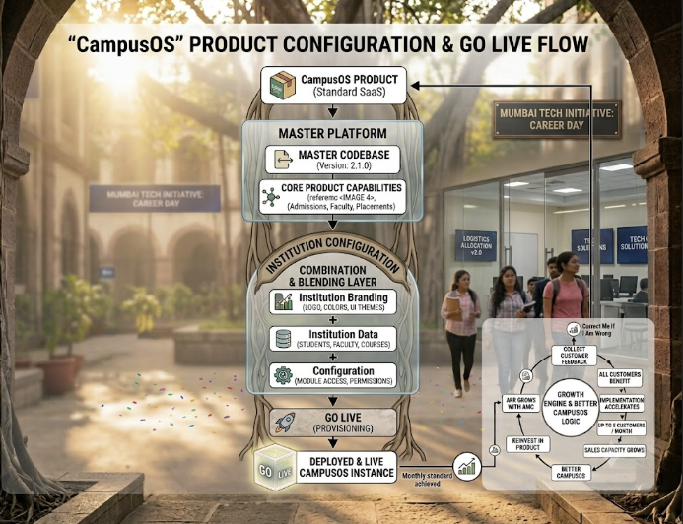The Five Core Statements
# | Statement
1 | ₹3.10L gets an institution onto CampusOS
2 | We configure the same platform; we don't rebuild the website
3 | Customer requirements drive the next product capabilities
4 | Once developed, reusable capabilities become part of CampusOS
5 | Every customer increases the value of the same product
Key Metrics
Metric | Value
Price per Institution | ₹3.10 Lakhs (Setup + Year 1 AMC)
Founding Partner AMC (Years 2-5) | Waived
Founding Partner AMC (Year 6+) | ₹60,000/year
Early Adopter AMC (Years 2-3) | Waived
Early Adopter AMC (Year 4+) | ₹60,000/year
Standard AMC | ₹60,000/year from Year 2
Target First Year | 5 Founding Institutions
Target Year 2 | 25 Institutions
Target Year 3 | 50 Institutions
Commercial Tiers
Tier | Clients | AMC Treatment
Founding Partners | 1-5 | AMC waived Years 2-5, ₹60K from Year 6
Early Adopters | 6-10 | AMC waived Years 2-3, ₹60K from Year 4
Standard | 11+ | AMC from Year 2 onward

SECTION 2: THE ₹3.10L CAMPUSOS PACKAGE
What's Included
Category | Components
Public Website | Home, Programs, Program Details, Admissions, Campus Tour, Career Services, Compliance, Institution Explorer
CampusOS Studio | Content management, Program management, Configuration, Preview, Publishing
AI Counsellor | Institutional FAQ, Knowledge repository, Search/retrieval, AI-assisted student interaction
Deployment | Institution branding, Content/data collection, Configuration, Testing, Training, Go-live, Initial support
What's Included in the AI Counsellor
Feature | Description
Institutional FAQ | Common questions about programs, fees, admissions
Knowledge Repository | Searchable institutional knowledge base
Search/Retrieval | Smart search across all content
AI-Assisted Interaction | Natural language Q&A for students and parents
AI Knowledge Setup | Repository configuration, FAQ configuration, Response validation
Current CampusOS Scope
✅ Included | ❌ Not Included (Yet)
Website + CMS | Fees & Finance Module
AI Counsellor | Parent Portal
Program Manager | Admissions CRM
Search | Executive Dashboard
Configuration Studio | Advanced AI (Grading, Exams)
Branding | Social Media Intelligence
SEO Foundation | Hostel Booking
Deployment & Training | Library Management
Standard Supported Payment Gateway | Placement Management
 | Digital Certificates
"Additional capabilities will be progressively introduced as part of the CampusOS product roadmap."

SECTION 3: THE PRODUCT RULE
The Most Important Rule for CampusOS
"If a capability can be reused by multiple institutions, it becomes part of CampusOS."
Instead Of | We Do
College A Website | CampusOS
College B Website | Configured for A
College C Website | Configured for B
 | Configured for C
The Three-Category Framework
Category | What It Means | Examples
Configuration | Included in ₹3.1L | Logo, Colors, Programs, Faculty, Fees, Admission info, Campus info, FAQ, Images, Policies
Product Feature | Build once, reuse for all | Fee Management, Parent Portal, Admissions CRM, Executive Dashboard
Customization | Separate commercial discussion | Unique workflows, ERP integration, Legacy migration, Custom development
Payment Gateway Rule
Scenario | Treatment
Standard Supported Payment Gateway | ✅ Included
Custom/Unsupported Payment Gateway | Separate commercial discussion

SECTION 4: COMMERCIAL BENEFIT STRUCTURE
Commercial Tiers
Tier | Clients | AMC Treatment | Benefit Period
Founding Partners | 1-5 | AMC waived Years 2-5 | 5 years
Early Adopters | 6-10 | AMC waived Years 2-3 | 3 years
Standard | 11+ | AMC from Year 2 onward | None
Founding Partner Program (Clients 1-5)
Aspect | Detail
Investment | ₹3.10 Lakhs (Setup + Year 1 AMC)
AMC (Years 2-5) | Waived
AMC (Year 6+) | ₹60,000/year
Benefit Period | 5 years
Benefits:
Benefit | Description
Standard Platform Updates | All core platform updates included
Standard Product Enhancements | New features released during benefit period
Priority Support | Faster response times
Early Access | Beta features before general release
Product Roadmap Participation | Shape the product direction
Preferential Pricing | Discounted rates on premium modules and integrations
Early Adopter Program (Clients 6-10)
Aspect | Detail
Investment | ₹3.10 Lakhs (Setup + Year 1 AMC)
AMC (Years 2-3) | Waived
AMC (Year 4+) | ₹60,000/year
Benefit Period | 3 years
Benefits:
Benefit | Description
Standard Platform Updates | All core platform updates included
Standard Product Enhancements | New features released during benefit period
Priority Support | Faster response times
Standard Commercial Terms (Clients 11+)
Aspect | Detail
Investment | ₹3.10 Lakhs (Setup + Year 1 AMC)
AMC (Year 2+) | ₹60,000/year
Summary Table
Client Range | Setup + Year 1 AMC | Years 2-3 AMC | Years 4-5 AMC | Year 6+ AMC
1-5 | ₹3.10L | Waived | Waived | ₹60K/year
6-10 | ₹3.10L | Waived | ₹60K/year | ₹60K/year
11+ | ₹3.10L | ₹60K/year | ₹60K/year | ₹60K/year
Exclusions (Separately Chargeable)
Item | Description
ERP Integrations | Tally, SAP, Oracle, etc.
Custom/Unsupported Payment Gateways | Non-standard gateway setup
WhatsApp Business API | API integration
SMS Gateway | SMS integration
Custom Workflows | Institution-specific workflows
Legacy Data Migration | Large-scale data migration
Third-Party Integrations | Non-standard integrations
Custom Reports | Custom reporting requirements
Institution-Specific Development | Unique feature development

SECTION 5: PRODUCT VALIDATION OPPORTUNITIES
Not a Guaranteed Customer Sequence
"Customer need determines which capability gets developed next. The F1–F5 sequence is the preferred validation strategy, not a contractual product roadmap."
Institution | Preferred Focus | Why This Order
F1 — Foundation | Website + CMS + AI Counsellor | Prove we can deploy
F2 — Operations | Preferably institution with finance/fee requirements | Prove beyond website
F3 — Student Experience | Preferably institution with strong student/parent engagement needs | Prove student lifecycle
F4 — Admissions | Preferably institution with significant admissions activity | Prove revenue workflow
F5 — Executive | Preferably institution with management reporting requirements | Complete management story

SECTION 6: F1 — FOUNDATION INSTITUTION
Focus: Website + CMS + AI Counsellor
Aspect | Detail
Focus | Website + CMS + AI Counsellor
Modules | M01, M02, AI Counsellor Module
Activities | ~20
Timeline | 30-45 days
Goal | Prove deployment
What Gets Built
# | Activity | Module
1 | Institutional Profile Setup | M01
2 | Course/Department Mapping | M01
3 | Faculty Directory | M01
4 | CMS Implementation | M02
5 | Circular/Notice Publishing | M02
6 | Client Data Collection | —
7 | Database Setup | —
8 | Template Deployment | —
9 | Data Upload | —
10 | Branding Application | —
11 | Admin Training | —
12 | Faculty Training | —
13 | Client Approval | —
14 | Go-Live | —
15 | Role-Based Access Control | —
16 | SOP Documentation | —
AI Enablement
# | Activity | Module
17 | AI Knowledge Repository Setup | AI Counsellor
18 | FAQ/Knowledge Configuration | AI Counsellor
19 | AI Counsellor Configuration | AI Counsellor
20 | AI Response Validation | AI Counsellor
What F1 Gets
✅ Included | ❌ Not Included (Yet)
Modern Website | Fees & Finance Module
Content Management | Parent Portal
AI Counsellor | Admissions CRM
Search | Executive Dashboard
SEO Foundation | Advanced AI
Training & Support | Social Media Intelligence

SECTION 7: F2 — OPERATIONAL EXPANSION
Focus: Preferably Institution with Finance/Fee Requirements
Aspect | Detail
Focus | Fees + Notifications
Modules | M03, M06, T4, T5
Activities | 9
Timeline | 20-30 days
Goal | Prove CampusOS beyond website/content
What Gets Built
# | Activity | Module
1 | Fees Lookup Gateway | M03
2 | Standard Payment Gateway Integration | M06
3 | Online Fee Settlement | M06
4 | Fee Collection Dashboard | T4
5 | Outstanding Balance Display | T4
6 | Pending Installment Alerts | T4
7 | Automated Payment Reminders | T5
8 | Holiday Alteration Alerts | T5
9 | Absence Log Notifications | T5
Payment Gateway Note
Scenario | Treatment
Standard Supported Payment Gateway | ✅ Included
Custom/Unsupported Payment Gateway | Separate commercial discussion

SECTION 8: F3 — STUDENT EXPERIENCE
Focus: Preferably Institution with Strong Student/Parent Engagement Needs
Aspect | Detail
Focus | Student Dashboard + Parent Portal + Attendance
Modules | A02, A03, M05, T2
Activities | 10
Timeline | 20-30 days
Goal | Demonstrate student lifecycle capability
What Gets Built
# | Activity | Module
1 | Meeting Scheduler | A02
2 | Parent Consultation Booking | A02
3 | Parent Dashboard | A03
4 | Academic Progress Display | A03
5 | Attendance Display | A03
6 | Circular Distribution | A03
7 | Student Corner | M05
8 | Reference Materials Download | M05
9 | Attendance Logging | T2
10 | Instant Parent Notifications | T2

SECTION 9: F4 — ADMISSIONS
Focus: Preferably Institution with Significant Admissions Activity
Aspect | Detail
Focus | Enquiry Capture + Counselling + Pipeline + Conversion
Modules | A05C, A05T, T1, T3, E02
Activities | 16
Timeline | 20-30 days
Goal | Demonstrate revenue-generating institutional workflow
What Gets Built
# | Activity | Module
1 | Admission CRM (College) | A05C
2 | Landing Page Inquiry Capture | A05C
3 | University Portal Parsing | A05C
4 | Applicant Conversion Scoring | A05C
5 | Campus Visit Scheduling | A05C
6 | Counselor Follow-up Pipeline | A05C
7 | Batch Grouping | T1
8 | Course Structure Mapping | T1
9 | Fee Cycle Tracking | T1
10 | Digital Invoice Generation | T1
11 | Admission CRM (Tuition) | A05T
12 | Walk-in Inquiry Tracking | A05T
13 | Counselor Follow-up Configuration | A05T
14 | Parent-Counselor Consultation | A05T
15 | Conversion Ratio Tracking | A05T
16 | Intake Marketing Dashboard | A05T

SECTION 10: F5 — EXECUTIVE INSTITUTION
Focus: Preferably Institution with Management Reporting Requirements
Aspect | Detail
Focus | Executive Dashboard + KPIs + Alerts + Approvals + Executive AI Insights
Modules | C9
Activities | 8
Timeline | 20-30 days
Goal | Complete the management story
What Gets Built
# | Activity | Module
1 | Executive Analytics Dashboard | C9
2 | Enrollment Curve Tracking | C9
3 | Revenue Flow Tracking | C9
4 | Staff Attendance Analytics | C9
5 | Institutional Health Indicators | C9
6 | Executive Alerts & Notifications | C9
7 | Executive Approval Workflows | C9
8 | Executive AI Insights | C9
What F5 Does NOT Include (Moved to Add-on)
Module | Reason
Advanced AI (C3-C7) | Add-on
Social Media Intelligence (C10) | Add-on
Alumni Management (A01) | Core expansion later
Hostel Booking (A04) | Core expansion later
Library Management (M04) | Core expansion later
Placement Management (E01) | Core expansion later
Digital Certificates (E03) | Core expansion later
Smart ID Cards (E04) | Core expansion later

SECTION 11: FOUNDER TRANSITION
From Customer #5: Founder Changes Role
Phase | Founder's Role
Customers 1–4 | Product + Sales + Delivery
From Customer 5 | Sales + Product Strategy + Key Accounts
"Routine implementation moves to the Support/Implementation function. This prevents you from becoming the implementation bottleneck."

SECTION 12: STAFFING MODEL
Support / Implementation
Metric | Value
Ratio | 1 person : 5–10 institutions
When Added | Approximately Client #10
Responsibilities | Data collection, Content coordination, Configuration, Implementation, Training, Go-live, First-level support
Developer
Metric | Value
Ratio | 1 developer : up to 25 institutions
When Added | Around Client #5
Responsibilities | Product development, Bug fixing, Security, Performance, Releases, Common platform enhancements
"The developer should not become a college-specific developer."
Relationship Manager
Metric | Value
Ratio | 1 RM : up to 25 institutions
Responsibilities | Customer relationship, Regular reviews, Adoption, Feedback, Escalation, Renewal, References, Upsell opportunities
Sales
Metric | Value
Capacity Target | Up to 5 new institutions/month
When | From approximately Customer #10

SECTION 13: ORGANIZATIONAL SCALING
Customer Base | Core Organization | Trigger
1–4 | Founder + existing ₹1.5L/month operation | —
5–9 | + Developer ₹1L | Around Client #5
10–24 | + Sales + Support capacity | Around Client #10
25 | + Developer + RM | At 25 clients
26–49 | Add capacity based on workload | Ongoing
50 | Second 25-client operating block | At 50 clients
Scaling Rules
Rule | Value
Support/Implementation | 1 person per 5–10 institutions
Developer | 1 person per 25 institutions
Relationship Manager | 1 person per 25 institutions
Sales | Driven by up to 5-client/month acquisition capacity

SECTION 14: MONTHLY COST MODEL
Monthly Gross Operating Burn
Stage | Monthly Gross Operating Burn | Clients | Staff
Stage 1 | ₹1.5L | 1–4 | Founder
Stage 2 | ₹2.5L | 5–9 | Founder + Developer
Stage 3 | ₹4.0L | 10–24 | Founder + Developer + Support + Sales
Stage 4 | ₹5.5L+ | 25+ | Full team + additional capacity blocks
Monthly Net Cash Burn
"Net cash burn = Gross operating burn minus operating inflows (client collections, AMC payments, etc.). Typically ranges ₹3.5L–₹4.0L at Stage 3."
Cost Breakdown (Stage 3 — Gross Burn)
Component | Cost (₹)
Core Operations | ₹2.5L
Developer | ₹0.5L
Support | ₹0.5L
Sales | ₹0.5L
Total Gross Operating Burn | ₹4.0L
"This is a planning model, not an automatic hiring rule. Hiring activates when revenue, workload and pipeline justify it."

SECTION 15: FINANCIAL MODEL
Commercial Structure Summary
Client Range | Setup + Year 1 AMC | Years 2-3 AMC | Years 4-5 AMC | Year 6+ AMC
1-5 | ₹3.10L | Waived | Waived | ₹60K/year
6-10 | ₹3.10L | Waived | ₹60K/year | ₹60K/year
11+ | ₹3.10L | ₹60K/year | ₹60K/year | ₹60K/year
Revenue at Scale
Clients | Setup Revenue | Annual AMC | Total (Setup + Year 1 AMC)
1 | ₹2.50L | ₹0.60L | ₹3.10L
5 | ₹12.50L | ₹3.00L | ₹15.50L
10 | ₹25.00L | ₹6.00L | ₹31.00L
25 | ₹62.50L | ₹15.00L | ₹77.50L
50 | ₹1.25 Cr | ₹30.00L | ₹1.55 Cr
ARR at Scale
"50 clients = ₹1.55 Cr Year-1 revenue + up to ₹30L annual AMC run-rate"
Clients | Standard AMC Run-Rate | Actual ARR (Early Years)
10 | ₹6.00L | ₹6.00L
25 | ₹15.00L | ₹15.00L
50 | ₹30.00L | ₹30.00L
Note: For Founding Partners (1-5), AMC is waived for Years 2-5. Actual ARR will be lower until these customers enter the renewal period in Year 6.

SECTION 16: CASH RUNWAY & FINANCIAL KPI
Cash Runway
Metric | Value
Available Cash | [Your Cash on Hand]
Monthly Net Cash Burn | ₹3.5L - ₹4.0L
Runway (Months) | Available Cash ÷ Monthly Net Cash Burn
Financial KPIs
Metric | Description
Revenue/Client | ₹3.10L average
Monthly Gross Operating Burn | ₹4.0L at Stage 3
Monthly Net Cash Burn | Gross burn minus operating inflows
Gross Contribution | Revenue - variable costs
Customer Acquisition Cost (CAC) | Cost to acquire a client
Revenue per Employee | Total revenue / headcount
Annual Recurring Revenue (ARR) | AMC revenue
Cash Runway | Available cash ÷ monthly net cash burn
"Cash runway is critical around Client #10 when burn moves from ₹2.5L to ₹4L/month. Don't hire based on customer count alone — validate cash collection timing first."

SECTION 17: SALES ENGINE
Target Sales Capacity
Target sales capacity: Up to 5 new institutions/month (from Client #10 onward)
Illustrative Target Funnel
text
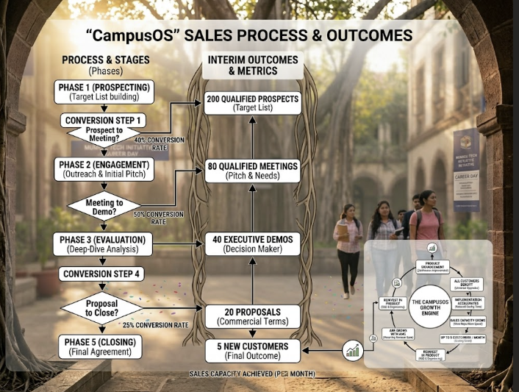Conversion Ratios (Planning Assumptions)
Stage | Conversion | Notes
Qualified Prospects → Meetings | 40% | Planning assumption
Meetings → Executive Demos | 50% | Planning assumption
Executive Demos → Proposals | 50% | Planning assumption
Proposals → Customers | 25% | Planning assumption
"These conversion ratios are planning assumptions, not validated CampusOS benchmarks. Replace with actual data after the first 20–30 sales conversations."
KPIs: Signed vs Live
Milestone | Signed Target | Live Target | Notes
First validation | 1 | 1 | —
Product validation | 3 | 3 | —
Founding institutions | 5 | 5 | —
Sales engine | 10 | 8 | Implementation lag
Scale milestone | 25 | 22 | Implementation lag
Product-company milestone | 50 | 45 | Implementation lag
"Live targets assume a normal implementation lag between contract signing and production go-live."

SECTION 18: TARGET CUSTOMERS (ICP)
Primary Decision Makers
Role | Pain Point
Principal | Admissions, Student experience, Digital presence, Administration
Trustee / Chairman | Visibility, Institutional growth, ROI, Modernization
Director / Management | Operations, Reporting, Efficiency, Automation
IT / Admin Head | Multiple systems, Maintenance, Integration, Security, Data
ICP Tiers
Tier | Target | Priority
Tier 1 | Private / autonomous colleges | ✅ Primary
Tier 2 | Junior colleges / education groups | ✅ Secondary
Tier 3 | Schools | 🔜 Future
Tier 4 | Coaching institutions | 🔜 Future
"I would initially avoid large government/university procurement cycles because they can slow down the first-customer learning loop."

SECTION 19: SALES MESSAGE
What NOT to Say
❌ "We create websites for colleges."
What TO Say
✅ "CampusOS gives your institution one digital platform for its website, content, operations, AI and future campus needs."
The Core Differentiation
✅ "You don't commission a new system every time you need another capability. CampusOS continuously evolves as a platform."
The Strategic Principle
✅ "Every customer increases the value of the same product."

SECTION 20: DEMO STRATEGY
30-Minute Demo Structure
Time | Segment | Focus
0–5 min | The Problem | Fragmented digital systems
5–10 min | Public Website | Show institutional experience
10–15 min | CampusOS Studio | How administrators manage website/programs
15–20 min | AI Counsellor | Institutional knowledge + AI interaction
20–25 min | Platform Roadmap | Admissions, Student, Faculty, Executive Dashboard, Compliance, Analytics
25–30 min | Business Model | ₹3.10L → Commercial benefits → Platform evolution
The Closing
"One platform. Configured for your institution. Continuously enhanced. ₹3.10 Lakhs deployment."

SECTION 21: PRODUCT DEVELOPMENT PRIORITY
🔵 CORE — Build First
Category | Modules
Institutional Website | M01, M02
CMS | M02
AI Counsellor | AI Counsellor Module
Programs | M01
Admissions | A05C, A05T
Student Lifecycle | M05, T2, T3, A03
Executive Dashboard | C9
Faculty | M01
Finance Basics | M03, M06, T4, T5
Compliance | M07
Notifications | T2, T5
User/RBAC | Security
Audit | Security
Backup | Security
Configuration | CMS Studio
Standard Supported Payment Gateway | M06
🟢 ADD-ON / OPPORTUNITY DRIVEN
Category | Modules
Advanced AI | C3, C4, C5, C6, C7
Social Media Intelligence | C10
Alumni Management | A01
Hostel Booking | A04
Library Management | M04
Placement Management | E01
Digital Certificates | E03
Smart ID Cards | E04
"These are valuable, but do not allow them to derail the core operating platform."
🟡 CUSTOM / PAID
Category | Examples
ERP integration | Tally, SAP, Oracle
WhatsApp Business API | C2
SMS | SMS gateway
Custom/Unsupported Payment Gateways | Non-standard gateways
Legacy migration | Data migration
Institution-specific workflows | Custom workflows

SECTION 22: THE 3-CUSTOMER RULE
Internal Development Rule
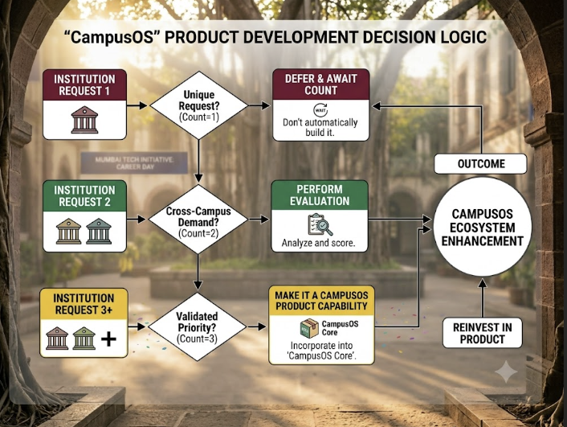"This is how we prevent CampusOS from becoming a custom software company."

SECTION 23: CUSTOMER SUCCESS STRATEGY
Standard Process
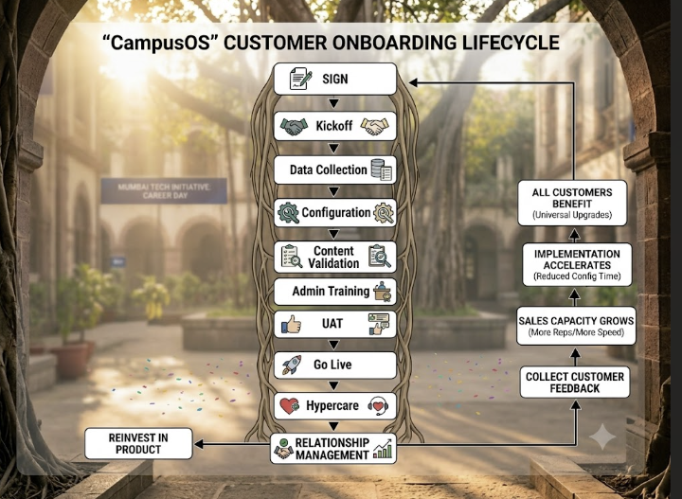
Implementation Targets
Client | Timeline
Client #1 | 30–45 days
Client #2–3 | 20–30 days
Client #5+ | 10–15 working days
"That reduction in implementation effort is one of the most important KPIs for CampusOS."
Go-Live Definition of Done
A customer is considered live when:
✅ | Criteria
☐ | Core content approved
☐ | Programs verified
☐ | Branding approved
☐ | AI knowledge validated
☐ | User accounts configured
☐ | Admin trained
☐ | UAT completed
☐ | Production deployment completed
☐ | Backup configured
☐ | Go-live approval received

SECTION 24: KPIS TO TRACK
Sales KPIs
Metric | Description
Prospects | Number of identified prospects
Qualified meetings | Meetings with decision-makers
Demos | Completed demonstrations
Proposals | Sent to prospects
Signed | Contracts signed
Live | Customers live on platform
Sales cycle | Time from first meeting to closure
Conversion rate | % of prospects that become customers
Product KPIs
Metric | Description
Reusable features % | % of features used by multiple clients
Bugs | Open/closed bug count
Release frequency | How often we release
Product adoption | Feature usage by clients
Implementation KPIs
Metric | Description
Days to go-live | From sign to launch
Support hours/client | Time spent per client
Data collection time | Time to get data
Configuration time | Time to configure
Customer KPIs
Metric | Description
Active institutions | Currently live
Adoption | Feature usage
Support tickets | Tickets opened
Satisfaction | NPS or satisfaction score
References | Willingness to provide references
Renewals | % renewing
Financial KPIs
Metric | Description
Revenue/client | ₹3.10L average
Monthly Gross Operating Burn | ₹4.0L at Stage 3
Monthly Net Cash Burn | Gross burn minus operating inflows
Gross contribution | Revenue - variable costs
Customer acquisition cost | Cost to acquire a client
Revenue per employee | Total revenue / headcount
Annual Recurring Revenue (ARR) | AMC revenue
Cash Runway | Available cash ÷ monthly net cash burn

SECTION 25: THE MAJOR MILESTONES
Commercial Milestones
Milestone | Signed Target | Live Target
First validation | 1 | 1
Product validation | 3 | 3
Founding institutions | 5 | 5
Sales engine | 10 | 8
Scale milestone | 25 | 22
Product-company milestone | 50 | 45
"Live targets assume a normal implementation lag between contract signing and production go-live."
What Each Milestone Proves
Milestone | What It Proves
1 Customer | Willingness to pay ₹3.10L
3 Customers | Repeatability
5 Customers | Productization (founder exits implementation)
10 Customers | Sales engine works
25 Customers | Operating machine is built
50 Customers | CampusOS is a scalable product business

SECTION 26: THE GTM FLYWHEEL
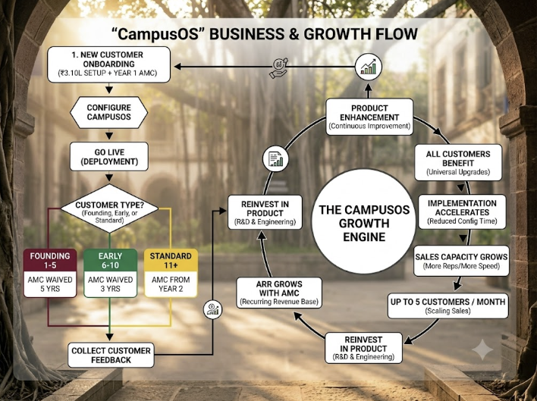
"Every customer increases the value of the same product."

SECTION 27: EXECUTION PLAN
Phase 1: Foundation (Months 1-3)
Priority | Action | Timeline
1 | ✅ Onboard Customer 1 (Foundation) | Month 1
2 | ✅ Build Phase 1 (Website + CMS + AI) | Month 1-2
3 | ✅ Go live with Customer 1 | Month 2
4 | ✅ Onboard Customer 2 (Operations) | Month 2-3
Phase 2: Founding Institutions (Months 4-9)
Priority | Action | Timeline
5 | ✅ Complete Customers 3, 4, 5 | Months 3-6
6 | ✅ Founder transitions to sales | Month 6
7 | ✅ Build sales engine | Month 6+
8 | ✅ Hire first developer | Month 5-6
Phase 3: Scaling (Months 10-24)
Priority | Action | Timeline
9 | ✅ Scale to 10 clients | Month 9-12
10 | ✅ Add Support + Sales capacity | Around Client #10
11 | ✅ Scale to 25 clients | Month 18-24
12 | ✅ Build operating machine | Month 24+
Phase 4: Product-Company (Months 25+)
Priority | Action | Timeline
13 | ✅ Scale to 50 clients | Month 36+
14 | ✅ Full team in place | Month 36+
15 | ✅ ARR run-rate ₹30L+ | Month 36+

SECTION 28: SUMMARY
Aspect | Status
Commercial Model | ✅ ₹3.10L with AI included
Founding Partner AMC (1-5) | ✅ Waived Years 2-5, ₹60K from Year 6
Early Adopter AMC (6-10) | ✅ Waived Years 2-3, ₹60K from Year 4
Standard AMC (11+) | ✅ ₹60K from Year 2
Product Reuse | ✅ "Configure, don't build"
5 Product Validation Opportunities | ✅ Foundation → Operations → Student → Admissions → Executive
Staffing Model | ✅ 1:5-10 support, 1:25 dev, 1:25 RM
Developer Added | ✅ Around Client #5
Support Added | ✅ Around Client #10
Revenue Engine | ✅ 50 clients = ₹1.55 Cr Year-1 revenue + up to ₹30L ARR run-rate
Sales Capacity | ✅ Up to 5 clients/month
Product Priority | ✅ Core → Add-on → Custom
3-Customer Rule | ✅ Prevents custom software trap
Milestones | ✅ 1 → 3 → 5 → 10 → 25 → 50
Go-Live Definition | ✅ 10-point checklist
Cash Runway | ✅ Defined with gross/net burn distinction

📞 Contact: [Your Contact Number]
📧 Email: [Your Email Address]
🌐 Website: [Campus OS Website]

